31.52: a) 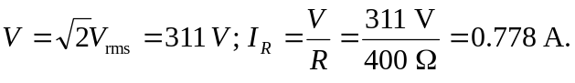
b) .
c) 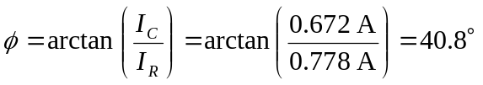, leading the voltage.
d) .
e) Leads since 

